**S2 METHODS: *P. falciparum* dynamics VivaxModelR ODE Equation (3) Description**

The compartmental model represents the host population where it is divided between infectious and susceptible individuals.

Models’ set of ODE equations can be represented as follows

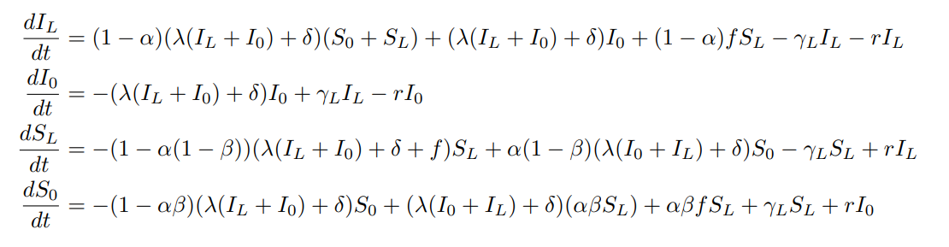

We let:

*TL* = proportion of blood-stage infected population with liver-stage infection which receive effective treatment

*T0* = blood-stage infected population without liver-stage infection which receive effective treatment

*UL* = blood-stage infected population with liver-stage infection but which do not receive effective treatment

*U0* = blood-stage infected population without liver-stage infection which do not receive effective treatment

*S0* = proportion of fully susceptible individuals

*SL* = individuals who have cleared their blood stage parasites but still harbour liver stage parasites and hence have the possibility to experience a relapse

We define $I≔TL+T0+UL+U0$ as the proportion of blood-stage infections

We modify the model *P. vivax* dynamics of liver clearance rate *gamma (γL),* and the relapse and reinfection frequency *f*, by setting the values *gamma = 1* and *f = 0*. We also set the parameter *beta (β)* to zero, defined as the probability that individuals clear their liver stage, an aspect of *P. vivax* dynamics, *β = 0*.

In this model, case management is represented by proportion of individuals receiving effective treatment (α), the proportion of individuals whose blood-stage parasites are effectively cleared due to treatment.

The observed incidence *h* is defined as;

***h =* [(𝜆𝐼∗+𝛿) (1−𝐼∗) +𝑓 S∗ 𝐿] ρ [(λI∗ +δ) (1−I∗) +fS∗ L​]**

Where *I∗* and *S∗L* are the equilibrium proportions for *I* and *SL* respectively and *ρ* is a reporting rate (proportion of infections that are effectively reported in the data

|  |  |  |  |
| --- | --- | --- | --- |
| **Parameters** | **Description** | **Unit** | **Definition range** |
| λ | Transmission rate | time−1 | ≥0 |
| r | Blood stage clearance rate | time−1 | ≥0 |
| γL | Liver stage clearance rate | time−1 | ≥0 |
| f | Relapse frequency | time−1 | ≥0 |
| δ | Importation rate | time−1 | ≥0 |
| α | Proportion of infections receiving effective treatment of blood stage parasites | . | [0,1] |
| β | Proportion of treated infections receiving effective radical cure | . | [0,1] |
| σ | Inverse of the duration of infectivity for treated infections | time−1 | ≥0 |
| ρ | Observation rate (proportion of new infections that are effectively reported) | . | [0,1] |